Q1

Q2



Q3

Q4







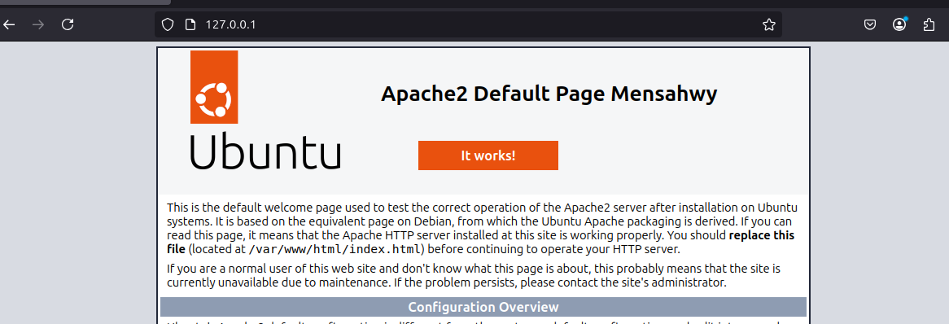

Q5

Not running   


Q6

Q7

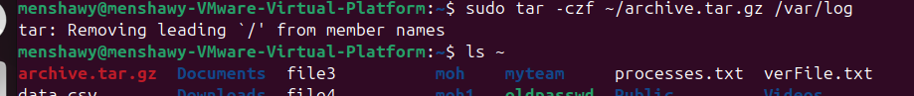

Q8





Q9



Q10



Q11

Q12



Q13

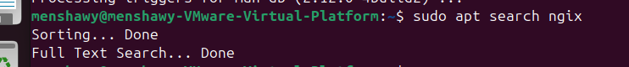

Q14

Q15

Q16

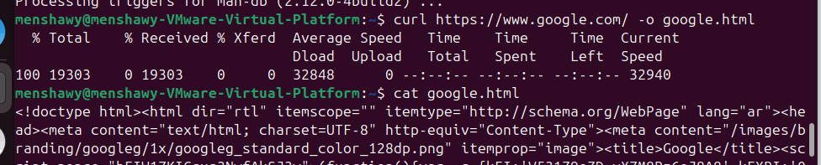

Q17

Can’t do it virtual box not working/ I will do on the same machine

Q18

Q19

Q20



Q21

